How to create a PPPoE dialer on a Windows 7 PC:

1. Connect your PC or Laptop directly via Ethernet to the “LAN” port on the NBN modem UNI-D1 port.
2. Open Network and Sharing Center, by right clicking on the below icon on your taskbar:





1. Select Set up net connection or network:



1. Select Connect to the Internet:



1. Select Broadband PPPoE:

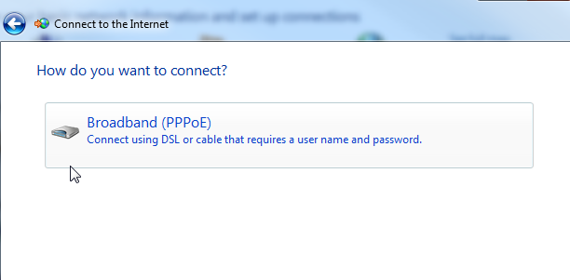

1. Enter your @clearmail.com.au email address & password (let us know if you do not have this on file), ensure that you call the connection something like “Clear Networks” and select connect:

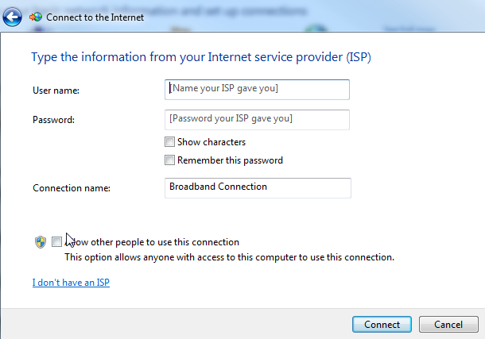

1. You are now connected to our network in isolation.